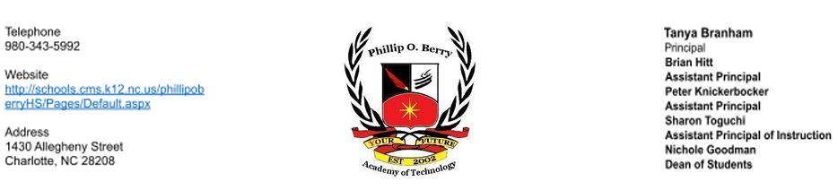

November 20, 2024

Dear Parent/Guardian:

I hope the school year has started successfully for all of you. As a parent/guardian of a student in Phillip O. Berry Academy of Technology, I am writing this letter to let you know that POB has been designated as a Targeted Support & Improvement-Consistently Underperforming (TSI-CU) school by the North Carolina State Board of Education. ESSA Section 1111(d)(2) stated that North Carolina had to identify schools for targeted support and improvement. TSI-CU schools in North Carolina have student subgroup(s) that are consistently underperforming.

This opportunity intends to improve educational outcomes for all students, close achievement gaps, increase equity, and improve the quality of instruction.

As a TSI-CU school, POB is required to develop a comprehensive plan that specifically addresses how the school will improve student achievement. The plan will also include how our district will support us and monitor our school's progress. The comprehensive plan will address the following areas:

● Classroom Management

● Standards-aligned Instruction

● Professional Learning Communities (PLCs)

● Instructional Leadership

● Recruitment & Retention of Effective Teachers

● Support for Grade-to-Grade Transitions

● Implementation of a Tiered Instructional System

● Data-Driven Decision Making

● Student Support Services

● Family and Community Engagement

We have set the following goals for POB this year:

● The percentage of high school students who score at the College and Career (CCR) level -- a 4 or 5 -- on the Math 1 EOC (grades 9-12) will increase from 7.7% in SY2023-24 to

18.1% in SY2024-25. (Aligns to A2.04 and B3.03 and CMS Goal 2)

● The percent of graduates earning a state high school endorsement will increase from 22.1% in SY2022-23 to 75% in SY2023-24. (Aligns to A4.16 and CMS Goal 3)

● We will increase our SWD subgroup from a F to a D or higher.

● We will meet or exceed expected Educator Value Added Assessment System (EVAAS) growth for our overall school index in SY2024-25. (95%)

● 100% of classroom teachers will implement Capturing Kids Hearts with fidelity (aligns to A1.07)

Our students need to experience higher achievement levels, but it will require hard work on the part of staff, students and families. Here are some strategies POB will be implementing:

● Use of various data points to identify students for small group instruction

● Providing after-school tutoring targeting SWD

● Common planning to ensure content alignment

● Utilizing Cardinal Block for additional interventions to target SWD

● Professional development focused on increasing student engagement and integrating core curriculum and CTE pathway curriculum across content areas

Parent engagement is at the heart of our school improvement efforts. Here are some ways we can work together:

● Make sure that both you and your student are aware of academic expectations set for your student this school year. A list of learning objectives in student-friendly language is available from your student’s teacher(s).

● Call Sharon Toguchi at sharonn.toguchi@cms.k12.nc.us if you have questions or concerns about your student or to set up an appointment to meet with a school staff member who will be working with your student.

● Make sure that your student is prepared and attends school each day.

● Monitor your student’s homework.

● Monitor the progress your student is making and attend meetings with your student’s teacher(s).

● Keep track of our website and social media sites. www.cmsk12.org/phillipoberryHS.

● Volunteer.

● Join POB PTSA

Sounds like a lot but preparing our students so that they can succeed is not easy and is a group effort. Here are some resources available to help:

● Graduation requirements: www.ncpublicschools.org/gradrequirements/

● K-12 standards in academic subjects: www.ncpublicschools.org/curriculum/

● State student achievement test results: www.ncpublicschools.org/accountability/

● N.C. School Report Cards: https://ncreportcards.ondemand.sas.com/src

We’re excited about this school year and are working to make it a success for your student(s).

If you have questions about the content of this letter, please contact Principal Tanya Branham at t.branham@cms.k12.nc.us or Assistant Principal of Instruction Sharon Tougchi at sharonn.toguchi@cms.k12.nc.us or call the school at 980-343-5993

Sincerely,

Tanya Branham